# Networks Lab 3

## RESOURCE 1 (The Friend Book)

### GET

1. Click on the “Your Friend Book” link in the landing page
2. Requires authentication:
   1. Username: admin
   2. Password: secret

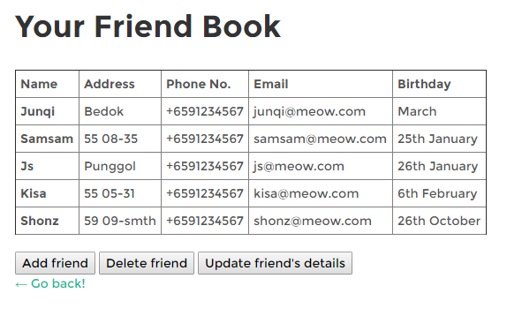



### POST

1. Click on the “Add friend” button
2. Enter all details
3. This function supports 2 types of POST
   1. Submission of a form
      1. Click on “Add Friend (form)”
   2. Submission using a JSON data object
      1. Click on “Add Friend (json)”

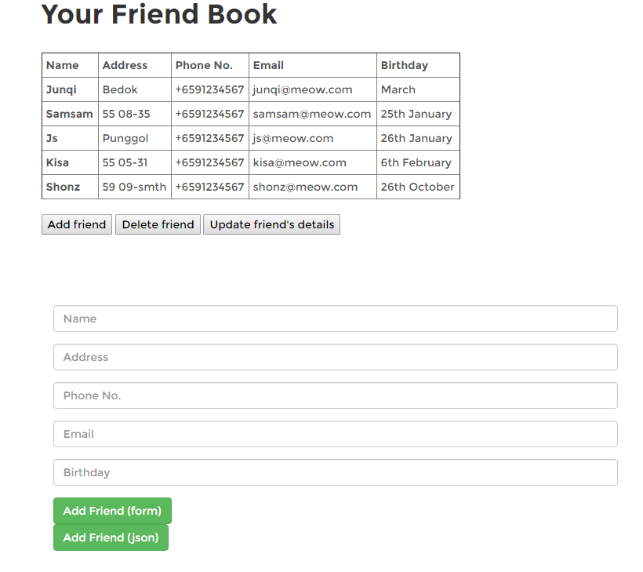

POST USING FORM



POST USING JSON OBJECT

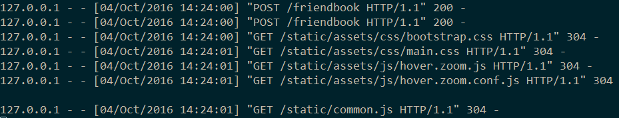

### DELETE

1. Click on “Delete friend” button
2. Pick the friend you want to delete
3. Click on “Delete Friend”

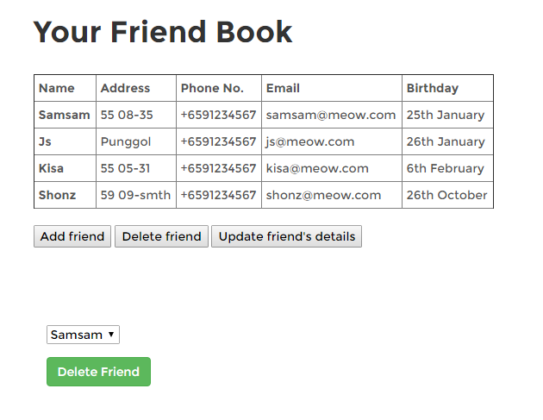

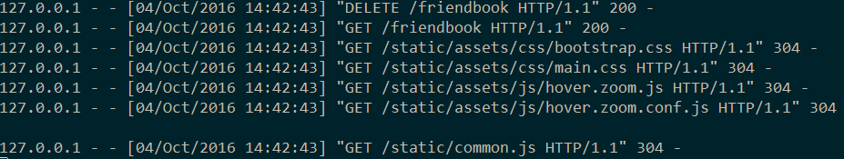

### PUT

1. Click on the “Update friend’s details” button
2. Choose the name of the friend whose details you would like to update
3. Insert the new details
4. Click on “Update Details”

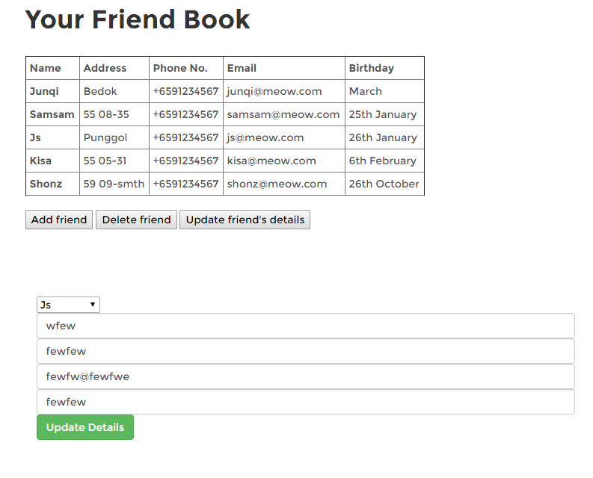

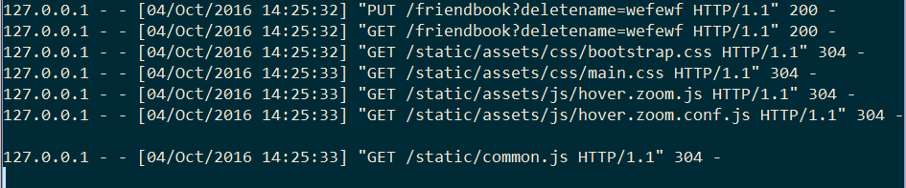

## RESOURCE 2

### GET

1. Enter a random word in the search bar in the landing page

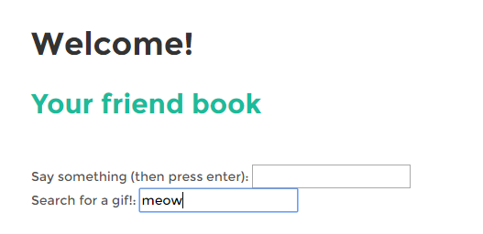

1. Press enter
2. The resource will show the history of searches done by the user

